#
# Планировавшиеся работы были отменены.
#
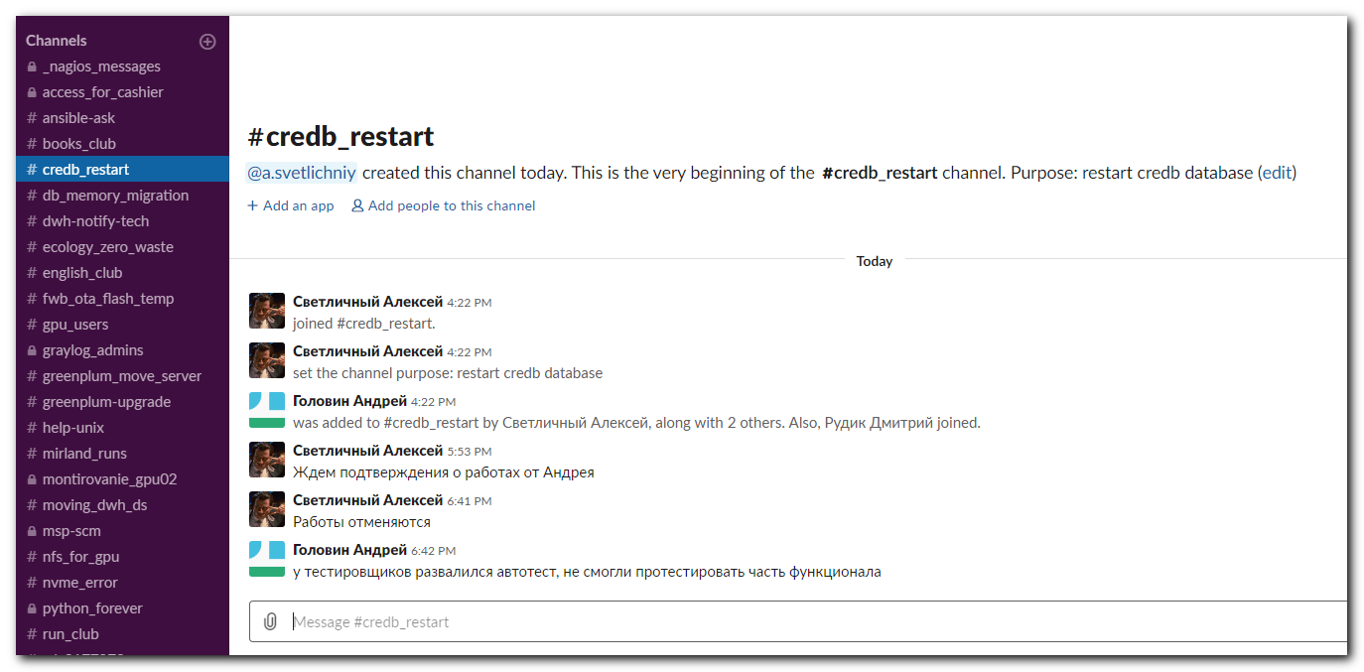

Ответственные:
oraDBA Светличный
Лоскутов
Unix Белогруд
Apps Головин
Место проведения работ:
CREDB
Описание работ:
Перезагрузка CREDB на второй узел кластера с перемещением TEMP на FLASH карту
Технические детали:

APPS опускаю приложения
UNIX Правят режим старта базы на CUSTOM
UNIX Создают на целевом сервере (ds-db29-prod2) файл

cat /opt/VRTSagents/ha/bin/Oracle/start_custom_CREDB.sql
startup mount

UNIX запускают переезд базы
DBA переименовывают TEMP файлы

alter database rename file '/oramnt/CREDB_prod_di01/temp001.dbf' to '/oramnt/flash/temp/CREDB/temp001.dbf';
alter database rename file '/oramnt/CREDB_prod_di02/temp002.dbf' to '/oramnt/flash/temp/CREDB/temp002.dbf';
alter database rename file '/oramnt/CREDB_prod_di03/temp003.dbf' to '/oramnt/flash/temp/CREDB/temp003.dbf';
alter database rename file '/oramnt/CREDB_prod_di04/temp004.dbf' to '/oramnt/flash/temp/CREDB/temp004.dbf';
alter database rename file '/oramnt/CREDB_prod_di05/temp005.dbf' to '/oramnt/flash/temp/CREDB/temp005.dbf';
alter database rename file '/oramnt/CREDB_prod_di06/temp006.dbf' to '/oramnt/flash/temp/CREDB/temp006.dbf';
alter database rename file '/oramnt/CREDB_prod_di07/temp007.dbf' to '/oramnt/flash/temp/CREDB/temp007.dbf';

DBA открыть БД

alter database open;

DBA Работы по Redefenition

UNIX в настройка Veritas нужно поменять режим старта на STARTUP
APPS запускают приложения

# For information.
[17:45:47 root@ds-db29-prod1 ~]# cat /opt/VRTSagents/ha/bin/Oracle/start_custom_CREDB.sql
cat: /opt/VRTSagents/ha/bin/Oracle/start_custom_CREDB.sql: No such file or directory
[17:46:38 root@ds-db29-prod1 ~]#

[17:45:45 root@ds-db29-prod2 ~]# cat /opt/VRTSagents/ha/bin/Oracle/start_custom_CREDB.sql
cat: /opt/VRTSagents/ha/bin/Oracle/start_custom_CREDB.sql: No such file or directory
[17:46:01 root@ds-db29-prod2 ~]# cat >> /opt/VRTSagents/ha/bin/Oracle/start_custom_CREDB.sql
startup mount
[17:46:17 root@ds-db29-prod2 ~]#

#
# Any changes not require.
#
[17:46:17 root@ds-db29-prod2 ~]# lsblk -o NAME,TYPE,MOUNTPOINT,FSTYPE,SIZE /dev/nvme0n1 /dev/nvme1n1
NAME TYPE MOUNTPOINT FSTYPE SIZE
nvme0n1 disk 1.5T
nvme1n1 disk 1.5T
└─nvme1n1p1 part /oramnt/flash/temp ext4 1.5T
[17:49:05 root@ds-db29-prod2 ~]#

[17:49:02 root@ds-db29-prod1 ~]# tail -f /var/VRTSvcs/log/engine_A.log
2019/09/16 06:43:15 VCS INFO V-16-1-53504 VCS Engine Alive message!!
2019/09/16 07:50:56 VCS WARNING V-16-1-50086 Mem usage on ds-db29-prod1 is 89%
2019/09/16 09:50:56 VCS WARNING V-16-1-50086 Mem usage on ds-db29-prod1 is 89%
2019/09/16 10:43:16 VCS INFO V-16-1-53504 VCS Engine Alive message!!
2019/09/16 11:50:56 VCS WARNING V-16-1-50086 Mem usage on ds-db29-prod1 is 89%
2019/09/16 13:50:56 VCS WARNING V-16-1-50086 Mem usage on ds-db29-prod1 is 90%
2019/09/16 14:43:17 VCS INFO V-16-1-53504 VCS Engine Alive message!!
2019/09/16 15:50:56 VCS WARNING V-16-1-50086 Mem usage on ds-db29-prod1 is 89%
2019/09/16 17:50:56 VCS WARNING V-16-1-50086 Mem usage on ds-db29-prod1 is 89%
2019/09/16 17:55:52 VCS INFO V-16-1-50133 User admin has logged in from ::ffff:172.16.28.74

[18:00:13 root@ds-db29-prod1 ~]#

#
# A place, where Veritas logs are.
#
[19:26:44 root@ds-db29-prod1 ~]# ls /var/VRTSvcs/log/
Application_A.log CmdSlave engine_A.log hastart.log HostMonitor_A.log IP_A.log Netlsnr_A.log NotifierMngr_A.log Oracle_A.log Phantom_A.log tmp vxfen
CmdServer-log_A.log CoordPoint_A.log hashadow-err_A.log healthview_A.log HostMonitor_B.log Mount_A.log NIC_A.log notifier-out_A.log Oracle_B.log Proxy_A.log uuidconfig.log
[19:26:48 root@ds-db29-prod1 ~]#

[18:00:13 root@ds-db29-prod1 ~]# hastatus -sum | grep -e "CREDB"
B OraCREDB ds-db29-prod1 Y N ONLINE
B OraCREDB ds-db29-prod2 Y N OFFLINE
B OraCREDB m1-db29-dr Y N OFFLINE
[18:00:55 root@ds-db29-prod1 ~]#

[18:00:55 root@ds-db29-prod1 ~]# mount | grep -e "CREDB" | awk '{print $1"\t"$3}'
a700-credb-prod-nfs:/CREDB_prod_di01 /oramnt/CREDB_prod_di01
a700-credb-prod-nfs:/CREDB_prod_di03 /oramnt/CREDB_prod_di03
a700-credb-prod-nfs:/CREDB_prod_di04 /oramnt/CREDB_prod_di04
a700-credb-prod-nfs:/CREDB_prod_di02 /oramnt/CREDB_prod_di02
a700-credb-prod-nfs:/CREDB_prod_di05 /oramnt/CREDB_prod_di05
a700-credb-prod-nfs:/CREDB_prod_arch /oramnt/CREDB_prod_arch
a700-credb-prod-nfs:/CREDB_prod_di06 /oramnt/CREDB_prod_di06
a700-credb-prod-nfs:/CREDB_prod_redo /oramnt/CREDB_prod_redo
a700-credb-prod-nfs:/CREDB_prod_home /opt/oracle/product/CREDB
a700-credb-prod-nfs:/CREDB_prod_di07 /oramnt/CREDB_prod_di07
a700-credb-prod-nfs:/CREDB_prod_di08 /oramnt/CREDB_prod_di08
[18:02:07 root@ds-db29-prod1 ~]#

